Report ASAS lab3

1.

...

2.

Generate window:

%windows

N=1000;

rectwin=ones(N);%rectangular window

for i=1:N

hamm(i)=0.54-0.46\*cos(2\*pi\*i/(N-1));% hamming window

end

for i=1:N

han(i)=0.5\*(1-cos(2\*pi\*i/(N-1)));% hann window

end

3.

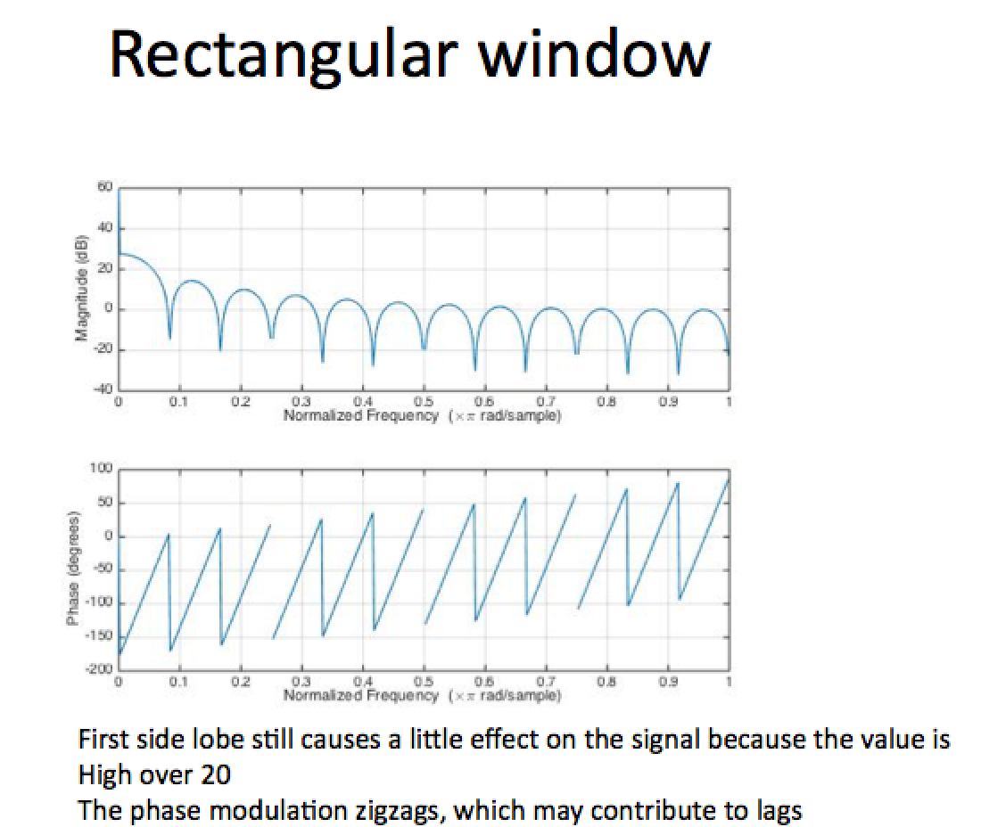

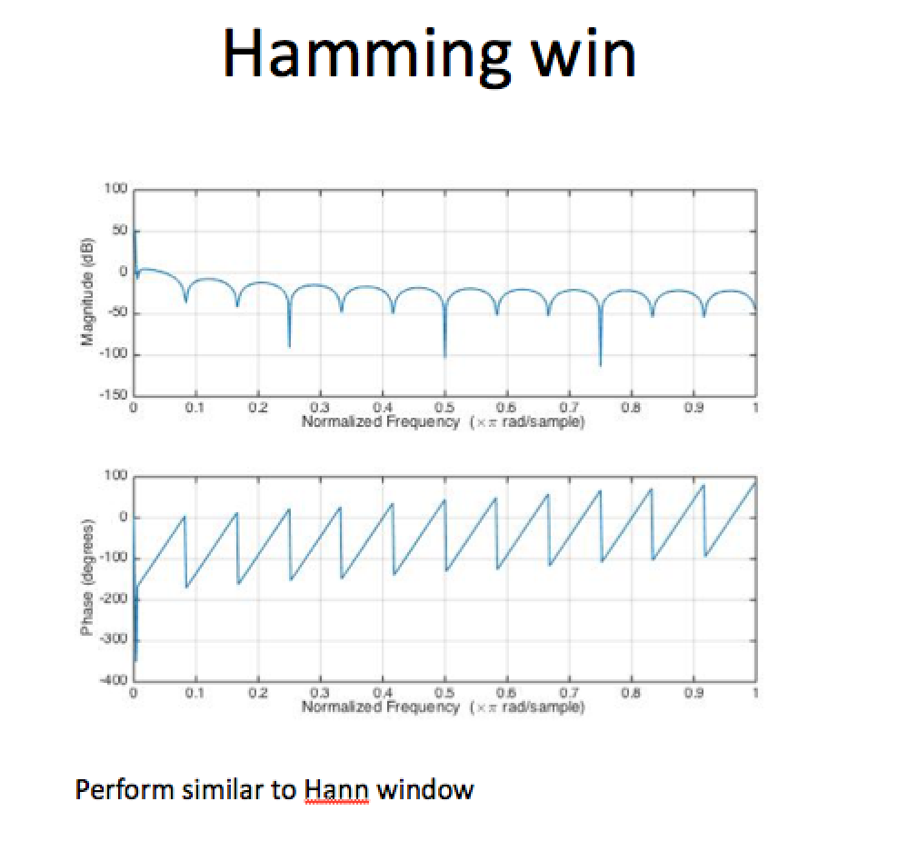

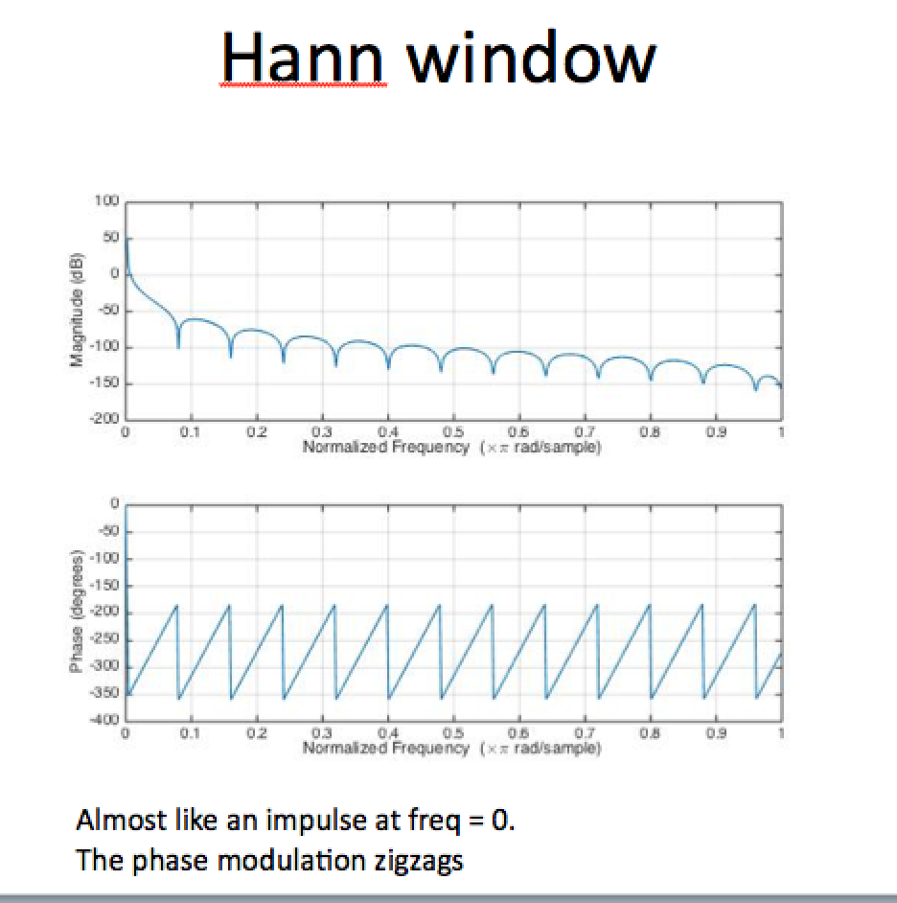

4.

The longer the overlap, the longer the spectrum. Overlaps contributes to showing the change in frequency.

5.

Higher duration makes the spectrogram shorter at the time axis and longer at the frequency axis, which means lower time resolution but higher frequency resolution

0.02:

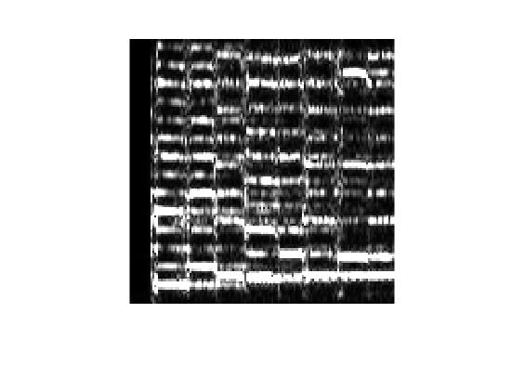

0.05:(I used the duration of 0.05 instead of 0.2 because the 0.2 duration window makes the spectrogram too narrow to analysis)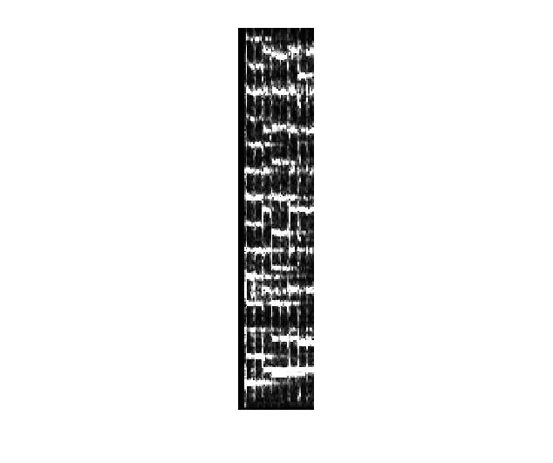

Further questions:

1.

To enhance the resolution on y-axis, we can prolong the window size, but that will result in low time resolution. In addition, we can increase the number of points of frequency sample. However, it reached to a limit since you are only using more points to record the frequency value.

2.

The kind of window depends on the application you are achieving. For example: if your are getting the fundamental frequency of your audio file, then you should select larger window(meanwhile you should check that the signals your are interested fit the window size, or you will get an averaged of interested signal and others). If you are just interested in the overall frequency of your audio file, you can take shorter window which tells you exactly when the signals happened. The last thing you have to think about is the overlap proportion of the window. Overlapping ensure that your signals looks continuous on the spectrogram.